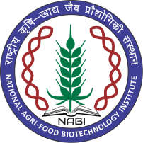 | NATIONAL AGRI-FOOD BIOTECHNOLOGY INSTITUTE  &  CENTER OF INNOVATIVE AND APPLIED BIOPROCESSING  (Deptt. of Biotechnology, Govt. of India)  Knowledge City, Sector 81, S.A.S. Nagar, Mohali 140306, Punjab, INDIA  Website: www.nabi.res.in; www.ciab.res.in  Tel. No. 0172-5221109 | 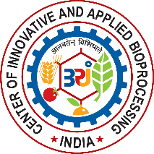

Advt No. NABI/4(10)/2010-Adhoc-2
Walk In Interview of Part Time Doctor for NABI-CIAB Campus

National Agri-Food Biotechnology Institute (NABI) and Center of Innovative and Applied Bioprocessing (CIAB) are two autonomous Institute under Department of Biotechnology (Govt. of India). Two Institutes have state of art research facilities and carry out globally competitive research in agriculture biotechnology and bio processing. NABI and CIAB campus located in Knowledge City (Sector-81) comprises of research laboratories of the two institutes as well as common staff residences and research scholars hostel.
Walk In Interview for part time medical doctor on the following terms & conditions:-
Qualification & Experience :-

MBBS registered with MCI with minimum Ten years’ experience in reputed hospitals / clinic / medical centers of educational institutions of similar type.
Nature of duty:-
The medical officer will be required to provide the Medical services to the students, faculty, staff and their family members.
Pay :-
Rs. 25000/- per month fixed. Salary negotiable for deserving candidate.
Maximum age limit:-

55 Years as on 14th June, 2018 .
Other:-
- This engagement will be initially for one year on purely temporary basis. The further extension of service will be on the basis of satisfactory performance.
- The medical officer will be required to perform the duties for two hours for six days a week.
- This contract appointment shall not give any right for appointment against any regular position at the Institute.
- Institute will not offer any other facilities such as Transport/Food etc.
- Candidates should bring original mark sheets/ Testimonials at the time of interview for verification.
- One month notice will be given by either party for the termination of engagement.
- Those who have applied earlier against Advertisement No.NABI/4(10)/2010-Adhoc need to attend the walk in interview.

All interested candidates may appear for Walk In Interview at National Agri-Food Biotechnology institute located at knowledge City, Sector-81, Mohali-140306 on 14th June, 2018 at 0900 hrs along-with updated CV/resume and a mandatory one-page cover letter written by the candidate describing the background and the reason and interest for applying to this particular position

The updated CV/resume and a mandatory one-page cover letter must be submitted at the time of registration from 0900 hrs to 1000 hrs on 14th June, 2018 (Thursday). The candidates must ascertain their eligibility before applying, as ineligible candidates will not be interviewed. No TA/DA will be paid for appearing in the interview. Canvassing in any form or bringing influence, political or otherwise, will lead to disqualification of the candidate(s). NABI may or may not select candidate against above mentioned position.

Manager (Administration)

